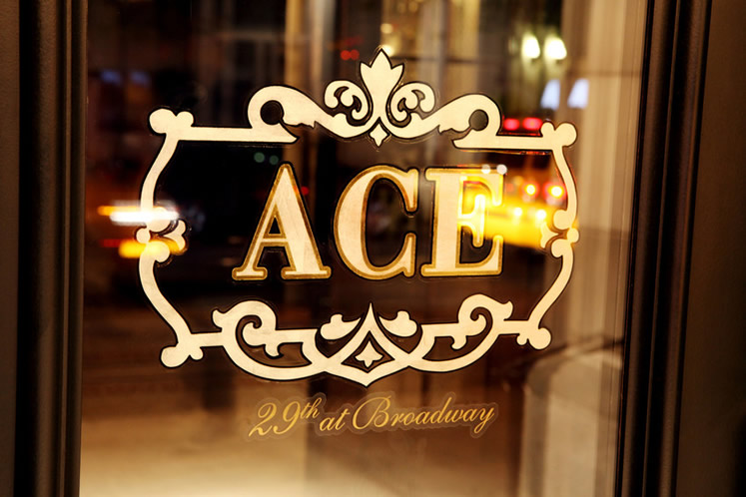
ACE HOTEL VACANCIES
100 Shoreditch High Street
London E1 6JQ

The ACE HOTEL are looking for energetic personalities with strong Hospitality knowledge that can work well under pressure in a team environment. Ideal candidates should be professional with a sense of humor and a strong passion for hospitality. Applicants must be very personable, patient, organized and detail oriented. we are looking for employees who are a hardworking, dedicated, professional demeanor and an appreciation for warm hospitality and are ready to relocate to the UNITED KINGDOM.

Employment Type: Full time

Hotel jobs available today – chef, asst. chef, Account Manager, Busboy, Cashier, Bartender, Assistant Manager of Front Office, Assistant restaurant manager, Housekeeper, Waiters/Waitress, Receptionist, Guest Relation Assistant, Room Attendant, Foreign/International Language Interpreter, Marketing Assistant Manager & Cafe Attendant/Manager etc. Hotel industry is directly related to hospitality and hence, customer service is the most vital part of this industry.

Have we piqued your interest in this versatile position? Then we look forward to your meaningful application documents. Gladly online! Applications and CV should be sent via acehotel@workmail.com

